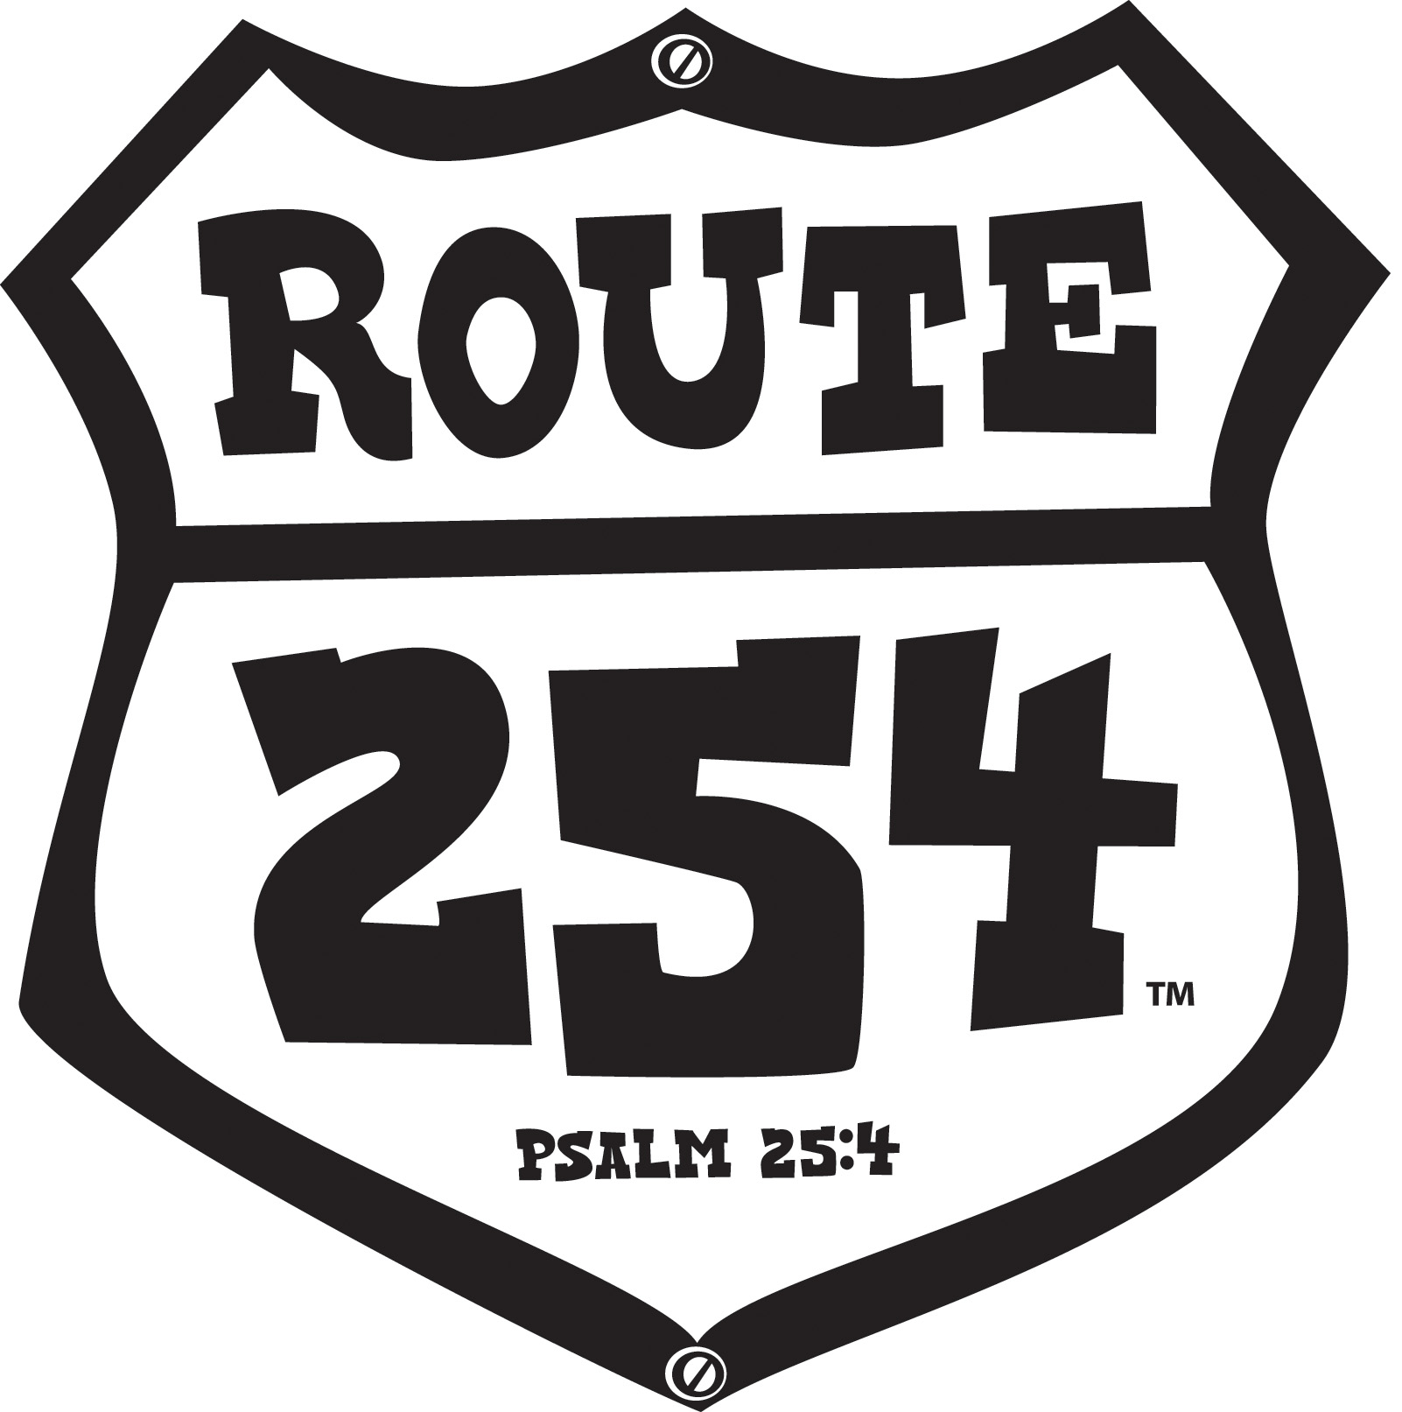

VBS 2010 Route 254 Preschool Base Conference Plan

Purpose Statement
This one hour plan is designed to prepare preschool leaders for conducting Club VBS using LifeWay’s Route 254 materials.

Resources to Collect
LifeWay’s Club VBS: Route 254 materials for Babies through Kindergarten
- Club VBS: Route 254 Administrative Guide Chapter 8
- Club VBS: Route 254 3s – K Leader Pack
- Club VBS: Route 254 3s – K Leader Guide
- Club VBS: Route 254 3s – K Learner Cards
- Snacks to place in conferees chairs
- Pens or pencils
- Markers and tear sheets
- 3 or more Wooden US puzzle (Teaching Step 1)
- 5 colors extra small adhesive dots (1 color dot per conferee)
- 2 inch die cut stars (one per conferee)

Resources to Prepare

Step 1
- Focal wall displays
- One 2 inch precut star per conferee
Step 3
- Make 5 travel bags using brown gift bags, cut off existing handle and attack a luggage handle using the letter “D”. Use markers to create the look of luggage around the edge of the bag. Place Route 254 logo on side of bag. Download Route 254 logo from LifeWay’s website: www.lifeway.com/clubvbs
- Make (5) assignments for travel bags (Pages 8 – 12)
- Make Bible Learning Center activities you would like to share with conferees; this will be based on time, space and budget. Conferees like to see finished activities.

Step 4
- Cut apart, mount on cardstock and laminate travel poster assignments (Page 13)

Pack supplies you will need for conference set-up:
Conference outline
Conference handouts
Markers, pencils, pens
Scissors
Nametags
Medium that is acceptable for putting visuals on wall
Extra plastic table clothes to cover unrelated theme items in room

Pack your decorations and supplies in suitcases or in items that can become part of your
Route 254 props.

Resources to Copy

Step 1
- 1 copy per conferee (Page 6)

Step 3
- 1 copy of each assignment page (Pages 7 - 11)
Step 4
- 1 copy for travel poster activity (Page 12)
- 1 copy per conferee (Page 13)

Focal Wall Description
Create a campsite atmosphere by hanging a painted canvas backdrop of an RV and trees. (A pop-up tent is another option for the campsite.) For depth, paint additional trees on foam board, cut out and prop in campsite. Extend a canopy over the door of RV. Crumble, tightly, brown paper bags to resemble rocks in order to create a campfire. Place “rocks” in a circle and add small pieces of wood to the center. Add a campstool, lantern, and other camping items to complete the campsite. Add props specific to the daily Bible Study. (Ex. Washington D.C., American Flag; Chicago, Bears or Cubs pennant; Lebanon, Sunflower; Yellowstone, stuffed wildlife animals; Knott’s Berry Farm, jar of jelly.) Make a sign from cardboard or foam board indicating BIBLE STUDY CAMPSITE, use markers to give a weathered look. Place a table near the RV backdrop and cover with a black cloth. A wide yellow ribbon can be placed down the center to resemble a centerline. Place Route 254 preschool materials and resources on table. Other suggestions can be found in the Club VBS: Route 254 Administrative Guide CD-ROM or by visiting LifeWay’s website: www.lifeway.com/clubvbs.

Room Setup Description
Place chairs in two semi-circles facing each other. Arrange chairs so there is enough space to allow conferees to work together and still see the focal wall. Place opening activity in center of semi-circle and place conference activities around room. If permitted place tear sheets on wall (Teaching Step 4). Place Page 7 and Page 14
under each chair.

Decoration Suggestions
Decorations for preschoolers should be left to a minimum. Preschoolers’ need their space therefore limit decorations mainly to outside the doorway, visuals hanging from the ceiling or placed on the wall.

- Using heavy paper, make an RV camper and place over door entrance
- Make an RV camper using a refrigerator box
- Place travel posters or maps on wall
- Hang theme related items from ceiling
- Place a pop-up tent in the room
- Additional ideas may be found in the Administrative Guide page 56 or in 3s – K Leader Guide

Audio Visual Needs

TV/DVD to show Worship Rally video

CD Player

Teaching Procedures

Step 1 Opening (5 minutes)
- As the conferees enter the room play “Route 254” (Instrumental Track 8)
CD from Grades 3s – K Leader Pack
- Greet and welcome the conferees at the door. Give each conferee a small dot to be placed on nametag. Ask conferees to look around Route 254 and then take a seat at the campsite. Ask conferees to introduce themselves to one another, tell favorite state they have visited and why. Ask conferees to work together to complete the puzzle.
- Give each conferee a star and “Play a Star Game” found on page 108 of the Administrative Guide.

Step 2 Packing for the Road Trip (15 minutes)
Say: “Tour guides, it is time to hit the road! The RV is packed and we are ready for some serious fun as we go cruisin’ coast to coast on Route 254. We will enjoy the sites of big cities, small towns, national parks and theme parks. But, most importantly, the Ramblers (preschoolers) will discover their true destinations are: Worship, Thankfulness, Kindness, Helpfulness and Obedience. Our preschoolers are always moving and on the go, so they will enjoy their Route 254 travels as they learn about being like Jesus. What a privilege we have to share Jesus’ love with little Ramblers, their families and our communities.”

Pray

Say: “What will we pack for our road trip? I need a volunteer?” Ask the volunteer to choose a friend and together they are to collect all the materials and resources for teaching Babies – 2s and 3s – K. Ask remaining conferees, who have their curriculum, to take out their materials and be ready to share with conferees that may not have their materials.

- Administrative Guide Chapter 8 - Babies – 2s
- 3s – K Leader Guide
- 3s – K Leader Pack
- 3s – K Learner Cards

Use this time to point out materials and resources available for Club VBS: Route 254. Refer to the Lifeway VBS catalog to acquaint conferees with other items available. Take a few moments to familiarize conferees with Administrative Guide, Leader Guide, Leader Pack and Learner Cards. Refer conferees to the instruction sheet in the Leader Pak and show how it is used with Leader Guide. Point out any items from the Leader Pack that you have used to decorate your room. Allow time for questions from the conferees about the materials.

Step 3 Cruisin’ Route 254 (20 minutes)
Say: “You will need to form five groups. Group yourselves based on the color dot you were given on arrival. One person from each group will select one of the 5 travel bags. In each travel bag you will find information pertaining to the five days of Bible Learning. Your assignment is to review with your group the route assigned and share your travel destination information with the rest of the tour guides when called upon. When you hear the moose sounds you will have one minute to complete your assignment.”

As conferees begin their assignments move to each group and answer any questions regarding assignments or for clarification of directions.

While conferees are working on their assignments softly play the song “Come a Travelin’” from 3s – K Leader Pack CD, Track 1. After five minutes play moose sounds from 3s – K Leader Pack, Track 13.

If you prepared Bible-Learning Center activities show those activities now.

Allow each group two minutes to present their assignments. Make helpful comments about each Bible Study when necessary. Allow time for conferees to ask questions.

Point out that they should feel more familiar with the Route 254 materials now that they have hands-on experience. Explain that preschoolers have a better learning experience when they do hands-on learning.

Step 4 Side Trips (15 minutes)
Say: “As we continue to cruise Route 254 you will find tear sheets posted on the wall. Move to one of the tear sheets and follow the instructions. When you hear the owl sounds you will have 1 minute to complete your travel poster.”

While conferees are working on their assignments play softly the song “Come a-Travelin’” found on 3s – K Leader Pack CD, Track 1. After 5 minutes play owls sounds found on 3s – K Leader Pack CD, Track 14.

Allow conferees 2 minutes to share their travel poster creations. Be ready to make additional comments in regards to these important areas of preschool ministry. Be
ready to share your ideas and personal experiences if the conferees are having a difficult time in doing so.

Step 5 Closing (5 minutes)
Ask if there are any questions about the materials that have been covered. Don’t let anyone leave without addressing his or her concerns. Be an encourager as they leave the conference.

Say: “We have not reached our final destination; we have many miles to go before we can unpack our RV. This is just the beginning of your road trip as you prepare to teach preschoolers. Thank you for your commitment to teach preschoolers about Jesus….”

Read Psalm 25:4

Say: “As we prepare for Route 254 let’s not forget why we do VBS. Let’s not forget to ask our Heavenly Father for direction and understanding as we prepare our hearts to teach.”

Pray

Pray for the conferees as they prepare for Club VBS: Route 254. Pray for the lives that will be transformed as a result of VBS.

Stand at the door and thank each conferee for coming. Remain in the room to answer questions.

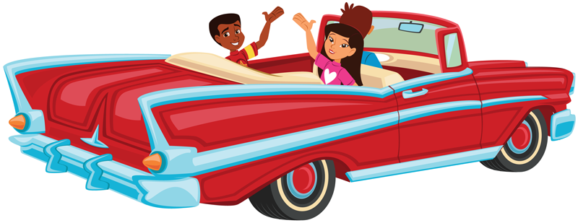
Cruisin' Route 254
With Preschool Ramblers

Club VBS: Route 254
What is your destination?
Ramblers Babies – 2s



Bible Story:
1. Bible Story
2. Bible Verse
3. Life Application
4. Levels of Biblical Learning
5. What is the Route 1 destination?
6. Describe a typical Route 1 Experience for Babies – Younger 1s.
7. Describe a typical Route 1 Experience for Older 1s – 2s.
8. How will the “star” be used in Recreation Time?
9. Describe the preparation that takes place prior to Snack Time.
10. As Preschool Ramblers prepare to go home, what actions need to be taken?
11. What needs to occur after the last child leaves?

Club VBS: Route 254
What is your destination?
Ramblers Babies – 2s



Bible Story:
1. Bible Story
2. Bible Verse
3. Life Application
4. Levels of Biblical Learning
5. What is the Route 2 destination?
6. How is Play a Touching Game used to communicate Route 2 Life Application for Babies – 1s?
7. How do the Older 1s and 2s say “Thank You” in the Enjoy Spinning Colors activity?
8. What useful margin tip can be found for Pretend to Cook?
9. How will the Bible Story Lesson be re-enforced in the Make Streamers activity?
10. During Recreation, how are the instructions different for Younger 1s and older 2s?
11. Where do you find the supply list for Babies – 2s activities?

Club VBS: Route 254
What is your destination?
Ramblers 3s - Kindergarten

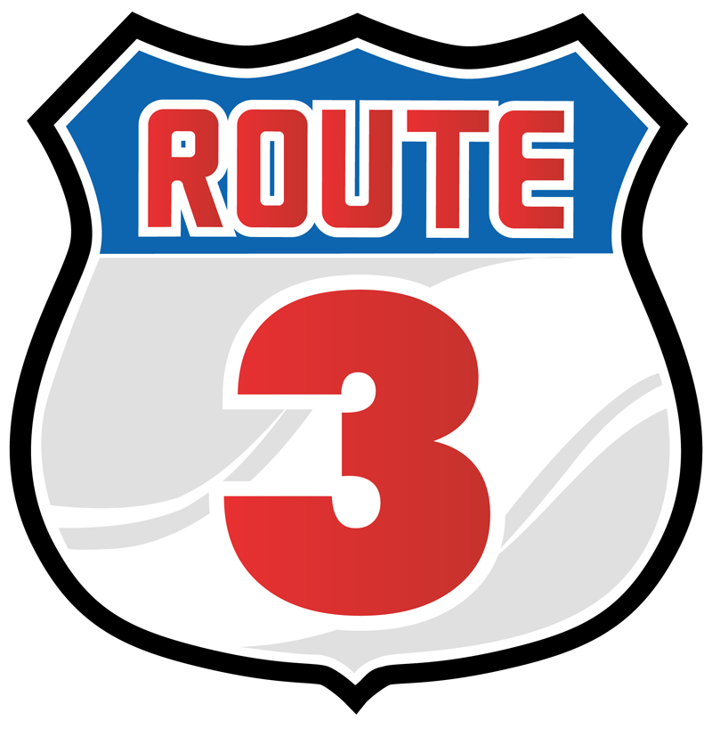

Bible Story:
1. Bible Story:

Bible Verse:
2. Life Application:

Levels of Biblical
Learning:
3. What is the Route 3 destination?
4. What will the Ramblers build in the Blocks Bible-Learning Center?
5. What will take place in the Homeliving Bible-Learning Center?
6. How will the Life Application be presented in the Nature Bible-Learning Center?
7. How will the Bible Learner Card 3 be used in Puzzles Bible-Learning Center?
8. Explain the Art Bible-Learning activity.
9. What is the margin tip for Local Attraction Bible-Learning activity?
10. Briefly describe what game will be played in Recreation Park.
11. What ingredients are needed for Snack Diner?
12. Describe what occurs during Prepare to Travel Home.
Club VBS: Route 254
What is your destination?
Ramblers 3s - Kindergarten

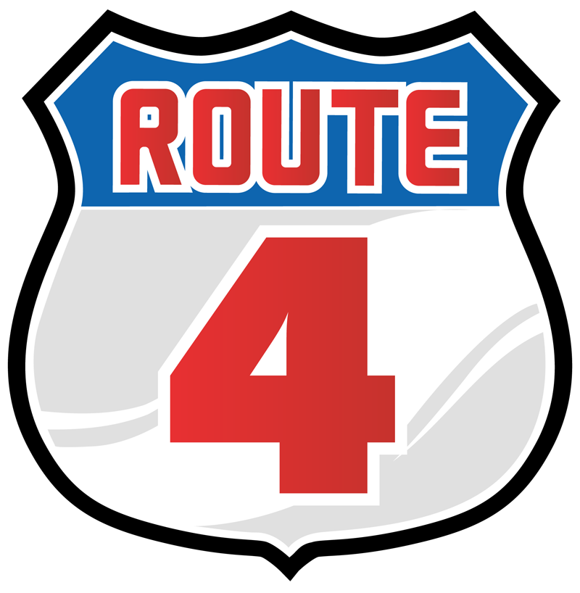

Bible Story:
1. Bible Study:

Bible Verse:
2. Life Application:

Levels of Biblical
Learning:
3. What is the Route 4
Destination?
4. Show the Leader Pack items needed for Blocks Bible-Learning Center?
5. How will the Learner Card 4 be used during Homeliving Bible-Learning Center?
6. What Leader Pack item is very important to Nature Stop Bible-Learning Center?
7. Using the margin tip, how can the Puzzles Bible-Learning Center be simplified?
8. How will the teaching picture be used during Art Bible-Learning Center?
9. How will Ramblers make the connection between waterfalls and the Bible story in Local Attraction Bible-Learning Center?
10. How is the Life Application applied in Recreation Park?
11. Compare the ease of preparing margin tip snacks to the Snacks Diner suggestion.
12. Show Leader Pack items needed for Prepare to Travel Home and tell how they are used.
Club VBS: Route 254
What is your destination?
Ramblers 3s - Kindergarten

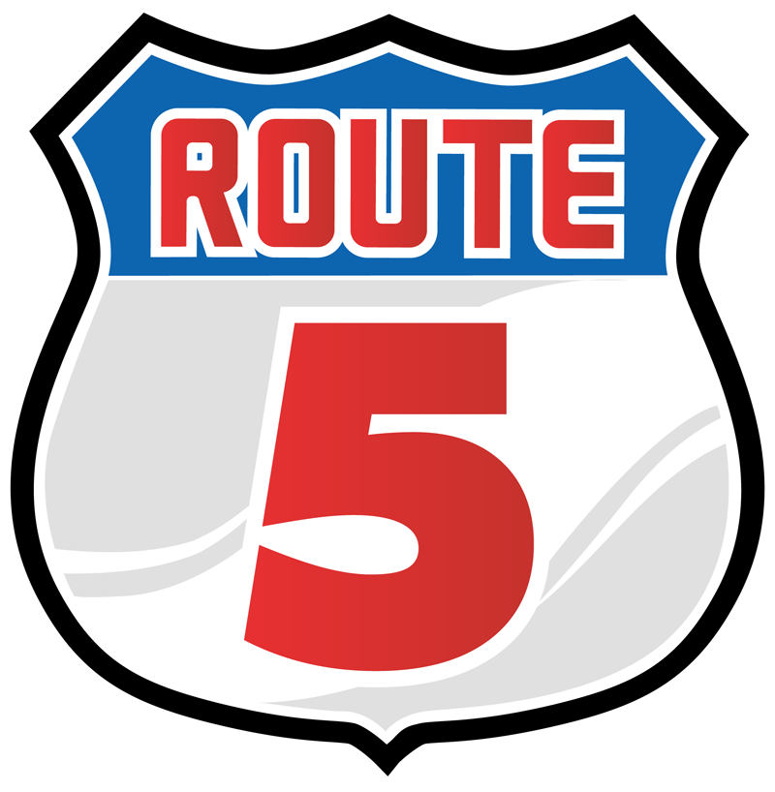

Bible Story:
1. Bible Study:

Bible Verse:
2. Life Application:

Levels of Biblical
Learning:
3. What is the Route 5
Destination?
4. What supplies are needed for Blocks Bible-Learning Center and how will they be used?
5. What Leader Pack items are needed for Homeliving Bible-Learning Center and how will they be used?
6. What area the Ramblers challenged to do in the Nature Bible-Learning Center?
7. How will the Leader Pack Item 24 be used in Puzzles Bible-Learning Center?
8. Explain how the Ramblers will design a bumper sticker in the Art Bible-Learning Center.
9. Using the margin tips, explain a less messy way to create fireworks in the Local Attraction Bible-Learning Center.
10. What will the Ramblers play in Recreation Park?
11. What are the Ramblers encouraged to do after they have eaten their snack at the Snacks Diner?
12. What is the guessing game the Ramblers will play in Prepare to Travel Home?

As you are cruisin’ Route 254 STOP . . . as a group, create a travel poster addressing preschool security and safety issues. Refer to Administrative Guide page 92 and to the 3s – K Leader Guide for help.

As you are cruisin’ Route 254 STOP . . . as a group, create a travel poster addressing preschool hygiene. Refer to Administrative Guide page 93 and the 3s – K Leader Guide for help.

As you are cruisin’ Route 254 STOP . . . as a group, create a travel poster for enlisting preschool tour guides. Refer to Administrative Guide page 14 and 3s – K Leader Guide for help.

STOP
STOP
STOP
STOP

As you are cruisin’ Route 254 STOP . . . as a group, create a travel poster for suggestions on additional decorating suggestions and ideas.
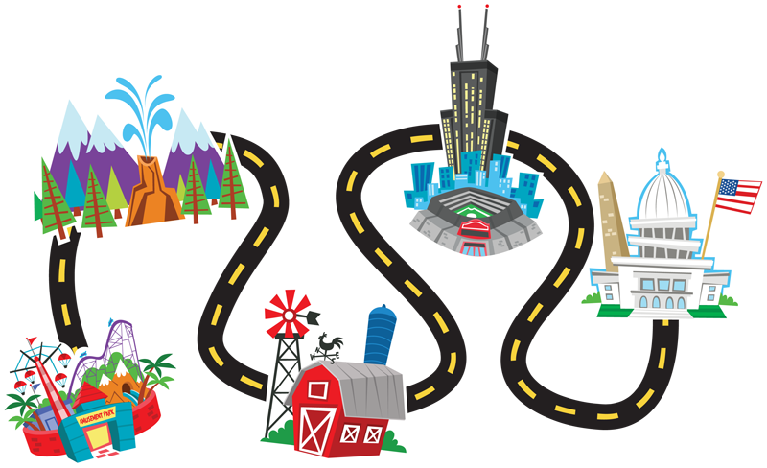

With Preschoolers

Mapping out a Successful Road Trip

- Security and Safety

- Hygiene

- Enlistment

- Decorating

